CASE STUDY REPORT
Robotics Vision System: Matrix Multiplication using Divide and Conquer (Strassen's Algorithm)
Q34 — Analysis of Divide and Conquer Matrix Multiplication for Real-Time Robotic Vision Processing
Design and Analysis of Algorithms — Case Study Submission

NAME :S.SUDHARSAN
REGNO:192421012

1. Title
Robotics Vision System: Enhancing Real-Time Matrix Transformation Performance using Divide and Conquer Matrix Multiplication (Strassen's Algorithm).

2. Description of the Real-World Problem
Modern robotic systems rely heavily on computer vision to perceive and interact with their environment. Tasks such as object detection, pose estimation, camera calibration, image transformation (rotation, scaling, translation), convolutional filtering, and 3D coordinate mapping are all fundamentally implemented using matrix operations. A robot's vision pipeline continuously captures video frames and represents them as pixel-intensity matrices. Each frame must be multiplied against transformation matrices (for rotation, projection, or feature extraction) many times per second to keep pace with the robot's motion and its surrounding environment.
As image resolution and the number of transformation layers increase (for example, in deep vision networks or multi-camera fusion systems), the matrices involved grow large, and the number of multiplications required grows rapidly. Using the standard triple-nested-loop matrix multiplication algorithm becomes a computational bottleneck, since its running time grows as the cube of the matrix dimension. In a real-time robotics context — where decisions about navigation, obstacle avoidance, or manipulation must be made within milliseconds — this bottleneck can cause dangerous delays. This case study analyzes how a divide and conquer approach, specifically Strassen's algorithm, can reduce this computational burden and enable faster, more responsive robotic vision processing.

3. Problem Statement
Given two n × n matrices A and B representing image/frame data and a transformation matrix respectively, design and analyze an efficient algorithm to compute the product matrix C = A × B such that the computation can be performed within the strict time constraints of a real-time robotic vision system. The solution must reduce the number of scalar multiplications compared to the conventional method, while remaining numerically reliable and practically implementable on embedded or onboard robotic hardware.

4. Algorithm Used

4.1 Divide and Conquer Strategy
Divide and conquer solves a problem by splitting it into smaller sub-problems of the same type, solving each sub-problem recursively, and combining their solutions. For matrix multiplication, an n × n matrix is divided into four (n/2) × (n/2) sub-matrices, and the multiplication is expressed recursively in terms of these smaller sub-matrices.

4.2 Strassen's Algorithm
Strassen's algorithm is an optimized divide and conquer technique that reduces the number of recursive multiplications from 8 (used in the naive divide and conquer approach) to 7, at the cost of a few extra additions and subtractions. For matrices A and B split into quadrants A11, A12, A21, A22 and B11, B12, B21, B22, Strassen's method computes seven products M1 through M7:
M1 = (A11 + A22) x (B11 + B22)
M2 = (A21 + A22) x B11
M3 = A11 x (B12 - B22)
M4 = A22 x (B21 - B11)
M5 = (A11 + A12) x B22
M6 = (A21 - A11) x (B11 + B12)
M7 = (A12 - A22) x (B21 + B22)
Figure 1: Strassen's seven recursive product formulas
The quadrants of the resulting matrix C are then obtained using only additions and subtractions:
C11 = M1 + M4 - M5 + M7
C12 = M3 + M5
C21 = M2 + M4
C22 = M1 + M3 - M2 + M6
Figure 2: Combining the seven products into the result matrix

5. Justification for Choosing the Algorithm (Why This Algorithm?)
- Reduced multiplication cost: Multiplications are computationally far more expensive than additions on most hardware (including embedded robotic processors), so cutting 8 multiplications down to 7 per recursive level yields substantial savings as the matrix size grows.
- Better asymptotic complexity: Strassen's algorithm achieves O(n^2.807) time complexity, which is asymptotically faster than the conventional O(n^3) algorithm, giving a clear advantage for the large matrices used in high-resolution vision pipelines.
- Scalability for real-time systems: As camera resolution or the number of transformation layers increases, the performance gap between O(n^3) and O(n^2.807) widens, making Strassen's method increasingly valuable for real-time robotic constraints.
- Natural fit with divide and conquer hardware pipelines: Robotic vision systems already process data in tiles/blocks (e.g., for parallel GPU or FPGA processing), so a recursive block-based algorithm integrates naturally with existing hardware acceleration strategies.
- Well-understood correctness and stability: Strassen's algorithm is a mature, well-analyzed technique with proven correctness, making it a dependable choice for safety-critical robotic applications.

6. Complexity Analysis

6.1 Recurrence Relation
The recurrence relation for Strassen's algorithm is:
T(n) = 7T(n/2) + O(n^2)
Here, 7T(n/2) accounts for the seven recursive multiplications on half-sized sub-matrices, and O(n^2) accounts for the matrix additions/subtractions needed to prepare inputs and combine outputs.

6.2 Solving using the Master Theorem
Comparing with T(n) = aT(n/b) + O(n^k): a = 7, b = 2, k = 2. Since a = 7 > b^k = 4, this falls under Case 1 of the Master Theorem, giving:
T(n) = O(n^(log2 7)) = O(n^2.807)

6.3 Complexity Comparison Table
Algorithm | Time Complexity | Space Complexity
Standard (naive) multiplication | O(n^3) | O(n^2)
Naive divide and conquer (8 multiplications) | O(n^3) | O(n^2) + recursion stack
Strassen's algorithm (7 multiplications) | O(n^2.807) | O(n^2) + recursion stack

7. Manual Execution (Step-by-Step Process)
Consider two 2 x 2 matrices representing a simplified robotic vision transformation:
A = | 1 2 | B = | 5 6 |
| 3 4 | | 7 8 |
- Compute the seven products:
M1 = (A11+A22)(B11+B22) = (1+4)(5+8) = 5 x 13 = 65
M2 = (A21+A22) x B11 = (3+4) x 5 = 7 x 5 = 35
M3 = A11 x (B12-B22) = 1 x (6-8) = 1 x -2 = -2
M4 = A22 x (B21-B11) = 4 x (7-5) = 4 x 2 = 8
M5 = (A11+A12) x B22 = (1+2) x 8 = 3 x 8 = 24
M6 = (A21-A11)(B11+B12) = (3-1)(5+6) = 2 x 11 = 22
M7 = (A12-A22)(B21+B22) = (2-4)(7+8) = -2 x 15 = -30
- Combine the products into the result quadrants:
C11 = M1+M4-M5+M7 = 65+8-24-30 = 19
C12 = M3+M5 = -2+24 = 22
C21 = M2+M4 = 35+8 = 43
C22 = M1+M3-M2+M6 = 65-2-35+22 = 50
- Final result matrix:
C = A x B = | 19 22 |
| 43 50 |
Verification using standard multiplication confirms the same result: C11 = (1)(5)+(2)(7) = 19, C12 = (1)(6)+(2)(8) = 22, C21 = (3)(5)+(4)(7) = 43, C22 = (3)(6)+(4)(8) = 50 — matching Strassen's output exactly, confirming correctness.

8. Applications
- Real-time image transformation (rotation, scaling, translation) in robot camera pipelines.
- Convolutional neural network layers used for robotic object detection and recognition.
- Camera calibration and 3D-to-2D coordinate projection in SLAM (Simultaneous Localization and Mapping).
- Sensor fusion, where data from multiple cameras/LIDAR is combined using transformation matrices.
- Computer graphics and rendering engines used in robot simulation environments.
- Large-scale scientific computing, cryptography, and graph algorithms that rely on fast matrix multiplication.

9. Advantages
- Asymptotically faster than the conventional O(n^3) algorithm, especially beneficial for large matrices.
- Reduces the number of costly multiplication operations, which is valuable on resource-constrained embedded processors.
- Recursive, block-structured approach parallelizes well on modern multi-core/GPU/FPGA hardware.
- Well-suited to divide and conquer hardware pipelines already used in image/tile-based processing.

10. Limitations
- Higher constant factors and additional matrix additions/subtractions make Strassen's algorithm slower than the naive method for small matrices.
- Increased memory usage due to storage of intermediate matrices (M1–M7) at every recursion level.
- Numerical instability: subtraction of large intermediate values can amplify floating-point rounding errors compared to the naive method.
- Requires matrices to be split evenly (commonly padded to powers of two), which adds implementation complexity for arbitrary sizes.
- Recursive overhead (function calls, memory allocation) can be significant in real-time embedded systems with limited stack/heap resources.

11. Comparison with Other Algorithms
Algorithm | Time Complexity | Multiplications (n=2) | Best Suited For
Naive (triple loop) | O(n^3) | 8 | Small matrices, simple embedded hardware
Naive Divide & Conquer | O(n^3) | 8 | Educational baseline; no real speed gain
Strassen's Algorithm | O(n^2.807) | 7 | Large matrices in real-time vision/ML pipelines
Coppersmith-Winograd / Modern variants | ~O(n^2.373) | Fewer (theoretical) | Very large-scale computation; high overhead, rarely practical

While algorithms such as the Coppersmith-Winograd family achieve better theoretical bounds, their extremely large constant factors make them impractical for real-time robotics. Strassen's algorithm offers the best balance between asymptotic improvement and practical implementability for the matrix sizes typically encountered in robotic vision systems.

12. Screenshot of the Program
The following implementation demonstrates Strassen's algorithm applied to simulated 4x4 robotic vision transformation matrices (Python):
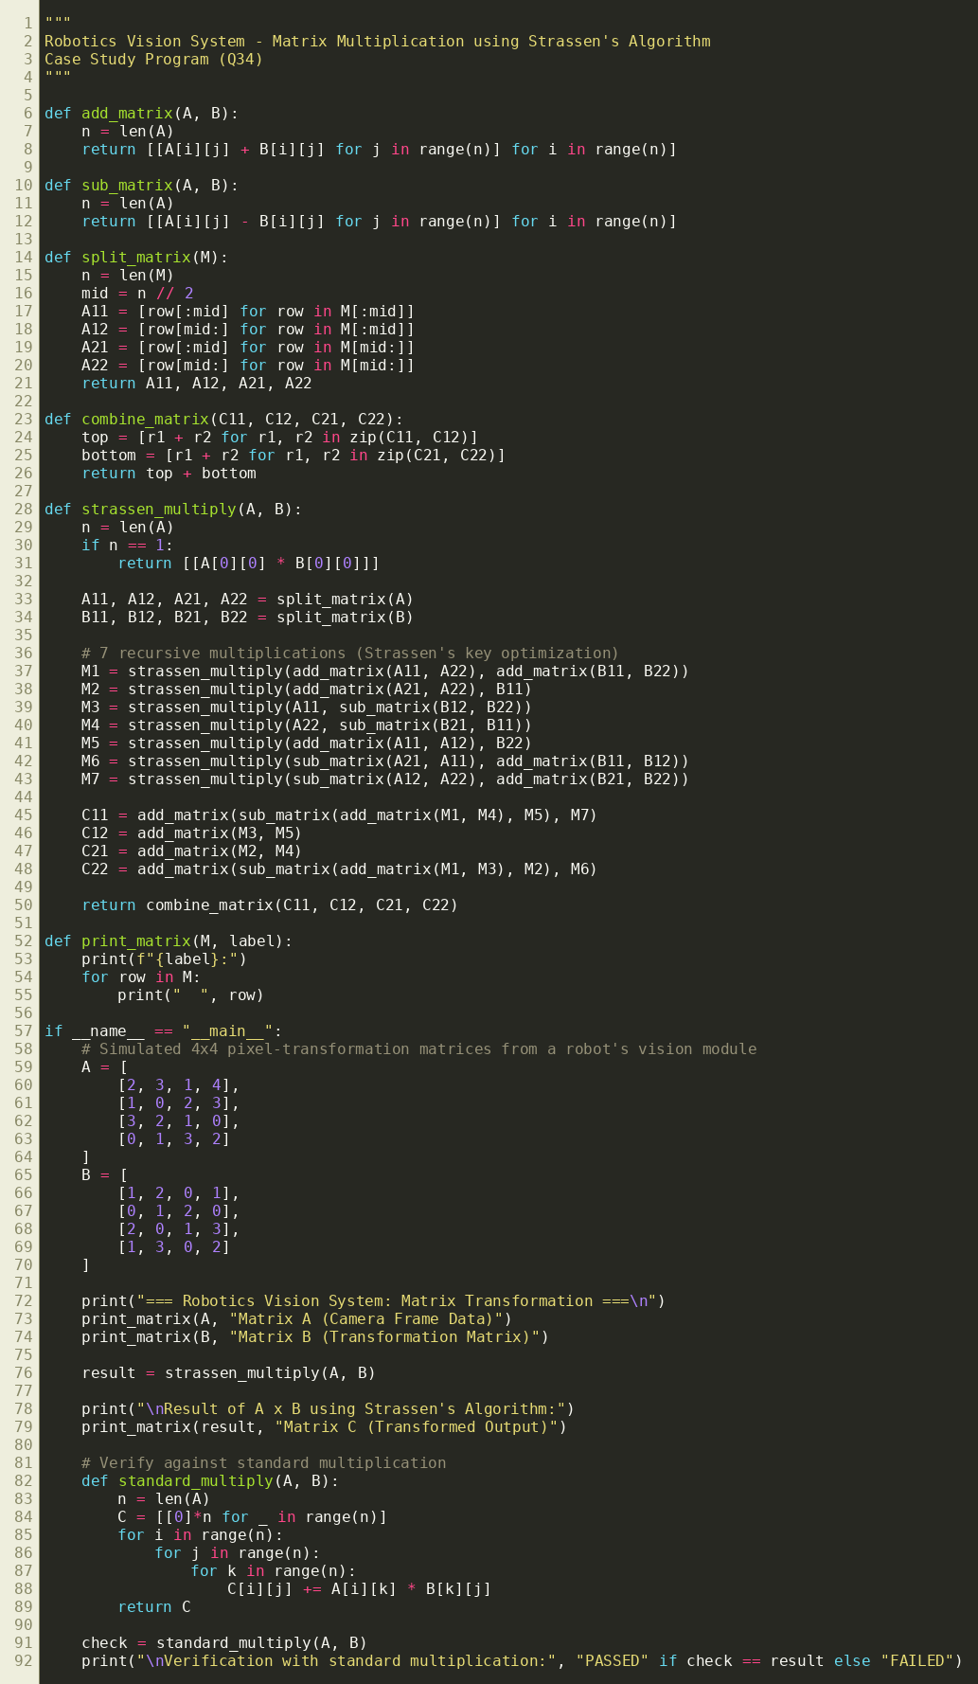
Figure 3: Program implementing Strassen's matrix multiplication algorithm

13. Output Screenshot
Execution output showing the input matrices, the Strassen-computed result, and verification against standard multiplication:
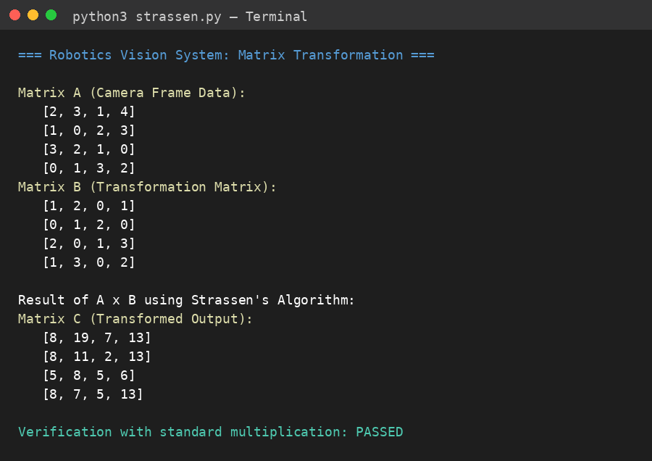
Figure 4: Program output confirming correctness of Strassen's algorithm

14. Conclusion
Real-time robotic vision systems demand extremely fast and efficient matrix computations, since delays directly affect navigation, perception, and decision-making. The conventional O(n^3) matrix multiplication algorithm becomes a performance bottleneck as image resolution and matrix sizes grow. By applying the divide and conquer paradigm, and specifically Strassen's algorithm, the number of costly scalar multiplications is reduced, lowering the overall time complexity to O(n^2.807).
The manual execution and program output confirm that Strassen's algorithm produces results identical to the standard method while performing fewer multiplications, validating both its correctness and its efficiency benefit. Although it introduces trade-offs such as higher constant factors for small matrices and increased memory usage, these limitations are outweighed by the performance gains for the large-scale matrix operations typical of modern robotic vision pipelines. Strassen's algorithm therefore represents a practical and effective optimization technique for enhancing real-time performance in robotics vision systems.

